# Homework: Delegates and Events

This document defines the homework assignments from the ["OOP" Course @ Software University](https://softuni.bg/courses/oop/). Please submit as homework a single zip / rar / 7z archive holding the solutions (source code) of all below described problems. The solutions should be written in C#.

## Custom LINQ Extension Methods

Create your own LINQ extension methods:

* **public static IEnumerable<T> WhereNot<T>(this IEnumerable<T> collection, Func<T, bool> predicate)**

Works just like **Where(predicate)** but filters the non-matching items from the collection.

Example:

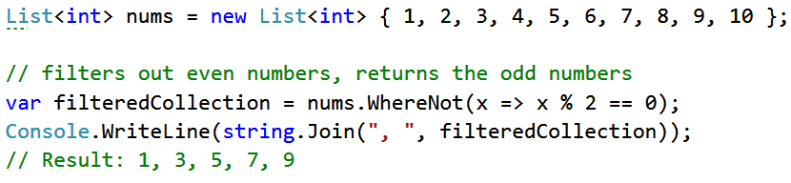

* **public static TSelector Max<TSource, TSelector>(this IEnumerable<TSource>, Func<TSource, TSelector>)**

The Max method works on a collection of type TSource (analogous to T, can be any type: int, string, Student, etc.). It accepts a Func<TSource, TSelector>, where TSelector is another type. For example, if we have a class Student and every student has a name and a grade of type int, the Max method may be applied on a collection of students and could return the maximal grade in the list of students. The Func would take a student and get the Grade property, then the method would compare all students’ grades and return the largest.

Example:

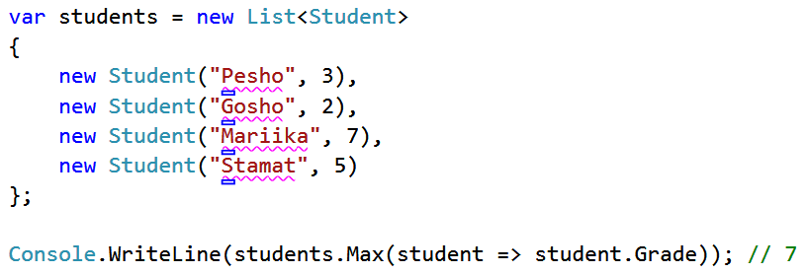

## Interest Calculator

Create a delegate **CalculateInterest** (or use **Func<…>**) with parameters **sum of** **money**, **interest** and **years** that calculates the interest according to the method it points to. The result should be rounded to 4 places after the decimal point.

* Create a method **GetSimpleInterest**(sum, interest, years). The interest should be calculated by the formula ***A = sum * (1 + interest * years)***.
* Create a method **GetCompoundInterest**(sum, interest, years). The interest should be calculated by the formula ***A = sum * (1 + interest / n)year \** *n***, where **n** is the number of times per year the interest is compounded. Assume **n** is always 12.

Create a class **InterestCalculator** that takes in its constructor **money**, **interest**, **years** and **interest calculation delegate**. Using this class calculate the interest for the following input parameters:

|  |  |  |  |  |
| --- | --- | --- | --- | --- |
| **Money** | **Interest** | **Years** | **Type** | **Result** |
| 500 | 5.6% | 10 | compound | 874.1968 |
| 2500 | 7.2% | 15 | simple | 5200.0000 |

## Asynchronous Timer

Create a class **AsyncTimer** that executes a given method each **t** seconds.

* The constructor should accept 3 arguments: **Action** (a method to be called on every **t** milliseconds), **ticks** (the number of times the method should be called) and **t** (time interval between each tick in milliseconds).
* The main program's execution **should NOT be paused at any time** (use some kind of background execution).

## Student Class

Write a class **Student** that holds name and age. Add an event **PropertyChanged** that should fire whenever a property of **Student** is changed, displaying a message in the format **Property changed: <property> (from <old value> to <new value>)**. Create a custom **PropertyChangedEventArgs** class to keep the property name, old value and new value. See the example below:

|  |  |
| --- | --- |
| **Sample Source Code** | |
| Student student = new Student("Peter", 22);  student.PropertyChanged += (sender, eventArgs) =>  {  Console.WriteLine("Property changed: {0} (from {1} to {2})",  eventArgs.PropertyName, eventArgs.OldValue, eventArgs.NewValue);  };  student.Name = "Maria";  student.Age = 19; | |
| **Sample Output** | |
| Property changed: Name (from Peter to Maria)  Property changed: Age (from 22 to 19) |